**Name: ……………………………………………………………… Stream: …..…………….**

**553/1  
BIOLOGY**(Theory) **April/2023**

**NYAKASURA SCHOOL  
MIDTERM 2 ASSESSMENT  
BIOLOGY  
S.3**

**Time: 1hour and 45 minutes**

**INSTRUCTIONS**

* Answer all questions.
* Answers to all questions **MUST** be written in the spaces provided

**SECTION A (30 MARKS)**

*(Answer all questions in this section)*

1. A group of senior 3 students of Nyakasura school set up the following apparatus of an experimement.

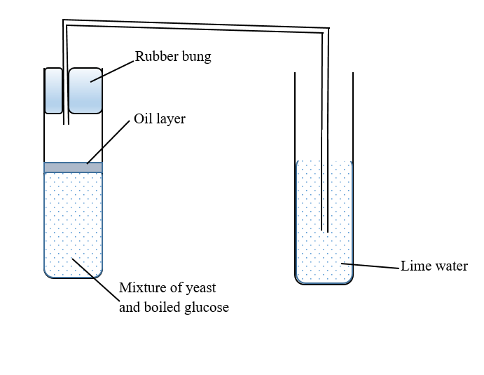

1. Formulate the aim of the experiment? (02 Marks)

…..............................................................................................................................................................................................................................................................................................................................................................................................................................................................

(b). Explain how the apparatus works. (04 Marks)

………………………………………………………………………………………………………………………………………………………………………………………………………………………………………………………………………………………………………………………………………………………………………………………………………………………………………………………………………………………………………………………………………………………………………………………………………………

(c). (i). Investigate what is expected to happen to the lime water. (03 Marks)

……………………………………………………………………………………………………………………………………………………………………………………………………………………………………………………………………………………………………………………………………………………………………………………………………………………………………………………………………………………………………………

(ii). Investigate what would happen if the boiling tube containing glucose and yeast was slightly warmed. (03 Marks)

……………………………………………………………………………………………………………………………………………………………………………………………………………………………………………………………………………………………………………………………………………………………………………………………………….

(d). What deduction can you make from this experiment? (01 Mark)

…………………………………………………………………………………………………………………………………………………………………………………………………….

(e). what was purpose of oil in this experiment? (02 Marks)

……………………………………………………………………………………………………………………………………………………………………………………………………

2. Nyamunyonyi, a cigarette smoker has been experiencing some health problems, especially shortage of breath when climbing stairs, frequent coughing and hypertension.

(a). Relate the difficulties faced by Nyamunyonyi to cigarette smocking. (06 Scores).

…………………………………………………………………………………………………………………………………………………………………………………………………………………………………………………………………………………………………………………………………………………………………………………………………………………………………………………………………………………………………………………………………………………………………………………………………………………………………………………………………………………………………………………………………………………………………………………………………………………………………………………………………………………………………………………………………………………………………………………………………………………………………………………………………………………………………………………………….

3. It can be argued that animal existence on earth would not be possible without the presence of green plants.

(i). In which ways is the animal existence dependent on plants? (04 Marks)

………………………………………………………………………………………………………………………………………………………………………………………………………………………………………………………………………………………………………………………………………………………………………………………………………….

(ii). Access the impact of destruction of plants on the quality of the environment. (05 Marks)

………………………………………………………………………………………………………………………………………………………………………………………………………………………………………………………………………………………………………………………………………………………………………………………………………………………………………………………………………………………………………….

**Section B (50 Scores)**

***(Answer only two questions from this section)***

**Question 4**

In the district athletics competitions held at Nyakasura playground, it was observed that the athletes took glucoses especially after heavy races. It was also evidenced that the athletes sweated while running and their shirts had unpleasant smell at the end of the day. In addition the athletes breathed at a higher rate after every race. Linda a senior one student picked much interest in understanding the scientific idea behind the observations above, however due to limited knowledge she could not fully understand the idea.

(a). How would you help Linda to clearly understand the scientific idea behind the observations made. **(10 scores)**

(b). Some senior two students had an argument whereby some students were of a view that germinating seeds produce heat while others were of a view that they absorb heat. For that reason, they decided to carry out an experiment to discover the truth. However they were worried of how to conduct the experiment. How would you help the learners be able to execute their experiment successfully? **(15 scores)**

**Question 5**

Bbaale is a village found in Kayunga district. This district is among the districts found in the cattle corridor. The residents often times face conflicts with some species of insects where by these insects bite them thus inflicting pain to them and even spreading some diseases. As if that is not enough the insects also bite their plants and animals thus ruining their health causing unrest and reduced productivity of the farms. The residents are carrying out a massive campaign to completely get rid of and creature called and insect.

(b). As the district agricultural officer of Kayunga, write a speech you would present to the people of kayunga about their concern. **(15 scores)**

(b). Kaliba thought that all small organisms including snails, earthworms, millipedes etc are insects. How would help Kaliba to know what insects are. **(02 Scores)**

(c). The table shows the characteristics of some insects.

|  |  |  |  |  |
| --- | --- | --- | --- | --- |
|  | Antenna | Mouth parts | Wings | Legs |
| A | Long | Mandibles | None | Short |
| B | Long | Proboscis | Has 2 | Short |
| C | Short | Proboscis | None | Long |
| D | Short | Proboscis | Has 4 | Long |
| E | Short | Proboscis | Has 4 | Short |

Construct a simple dichotomous key that can be used to identify the insects. **(08 Scores)**

**Question 6**

A group of learners were watching a video of various animals. As a result, an argument started among them regarding the classification of some animals.

One of such animals laid a large shelled egg and had scales on its body with a prominent tail. Some learners insisted that it was a reptile while others insisted that it was a mammal.

(a). Basing on your knowledge of classification, how would you conclusively resolve the argument between the two groups of learners? **(10 Scores)**

(b). The argument between the learners described above came about because the animal in question must be having some features that are common to both reptiles and mammals.

Describe three characteristics of this animal that place it the taxonomic group to which the mammals and reptiles belong. **(15 Scores)**

***SUCCESS IN YOUR ENDEAVORS***